Mac:

- Download Python 3.7 https://www.python.org/downloads/release/python-376/
- Install Python to local drive. While installing Python, please select ‘add python to PATH’
- Download pip https://bootstrap.pypa.io/get-pip.py
- Open the terminal and navigate to the folder containing get-pip.py
- Run the following command: python get-pip.py
- Once pip is installed on your machine, install virtual environment using the following link: https://sourabhbajaj.com/mac-setup/Python/virtualenv.html
- Download our project from github https://github.com/LiuYYSS/team_36
- Once you download our project, open a command prompt and navigate to the folder of our project.
- Run the following command to create a new python environment: py -m venv env
- Then, run the following command to activate the new environment: .\env\Scripts\activate
- Run the following command to install Microsoft vision API library: pip install --upgrade azure-cognitiveservices-vision-computervision
- Run the following command to install Microsoft text analytics API library: pip install --upgrade azure-cognitiveservices-language-textanalytics
- Go to https://azure.microsoft.com/en-gb/ register a new Microsoft azure account, and enter current billing information.
- Then go to azure portal https://portal.azure.com/, it should be similar to this 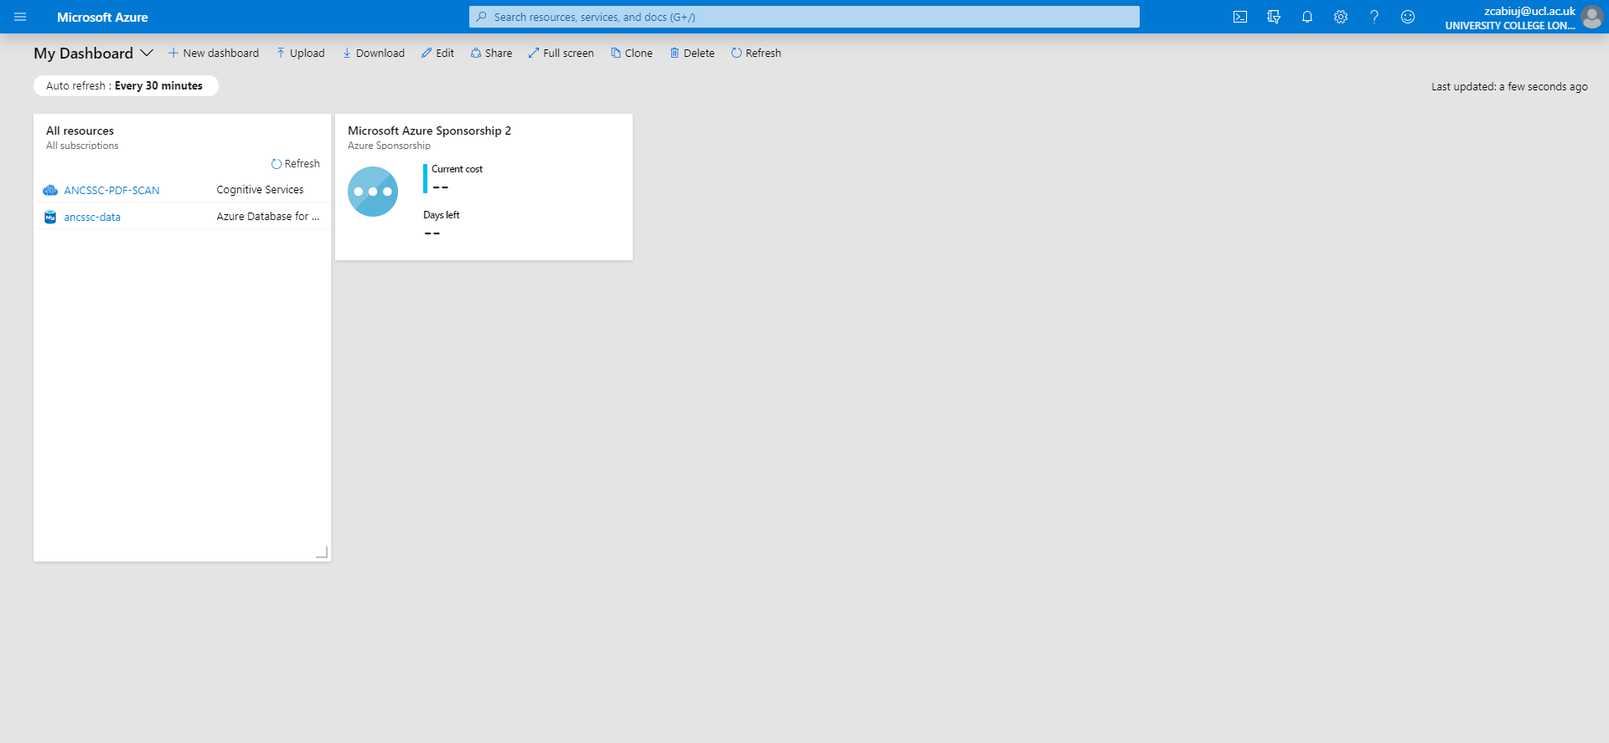
- Search ‘cognitive services’ on the search bar at top of this page, and click the cognitive services option.
- Click add
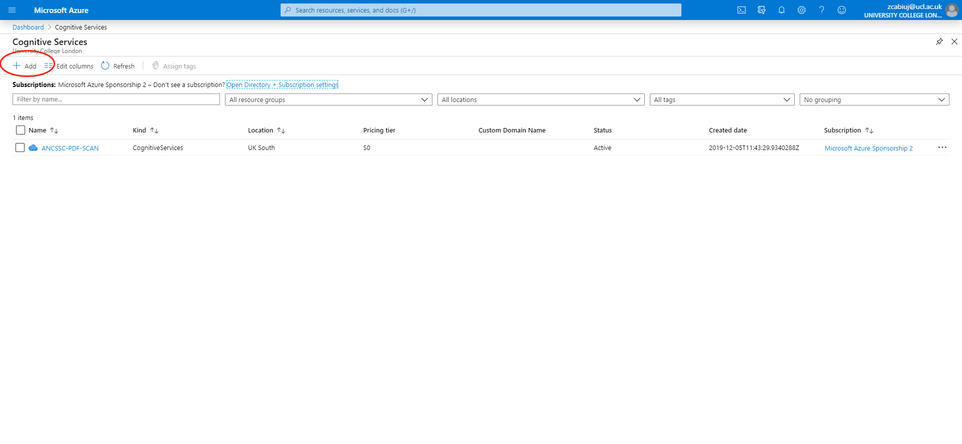
- 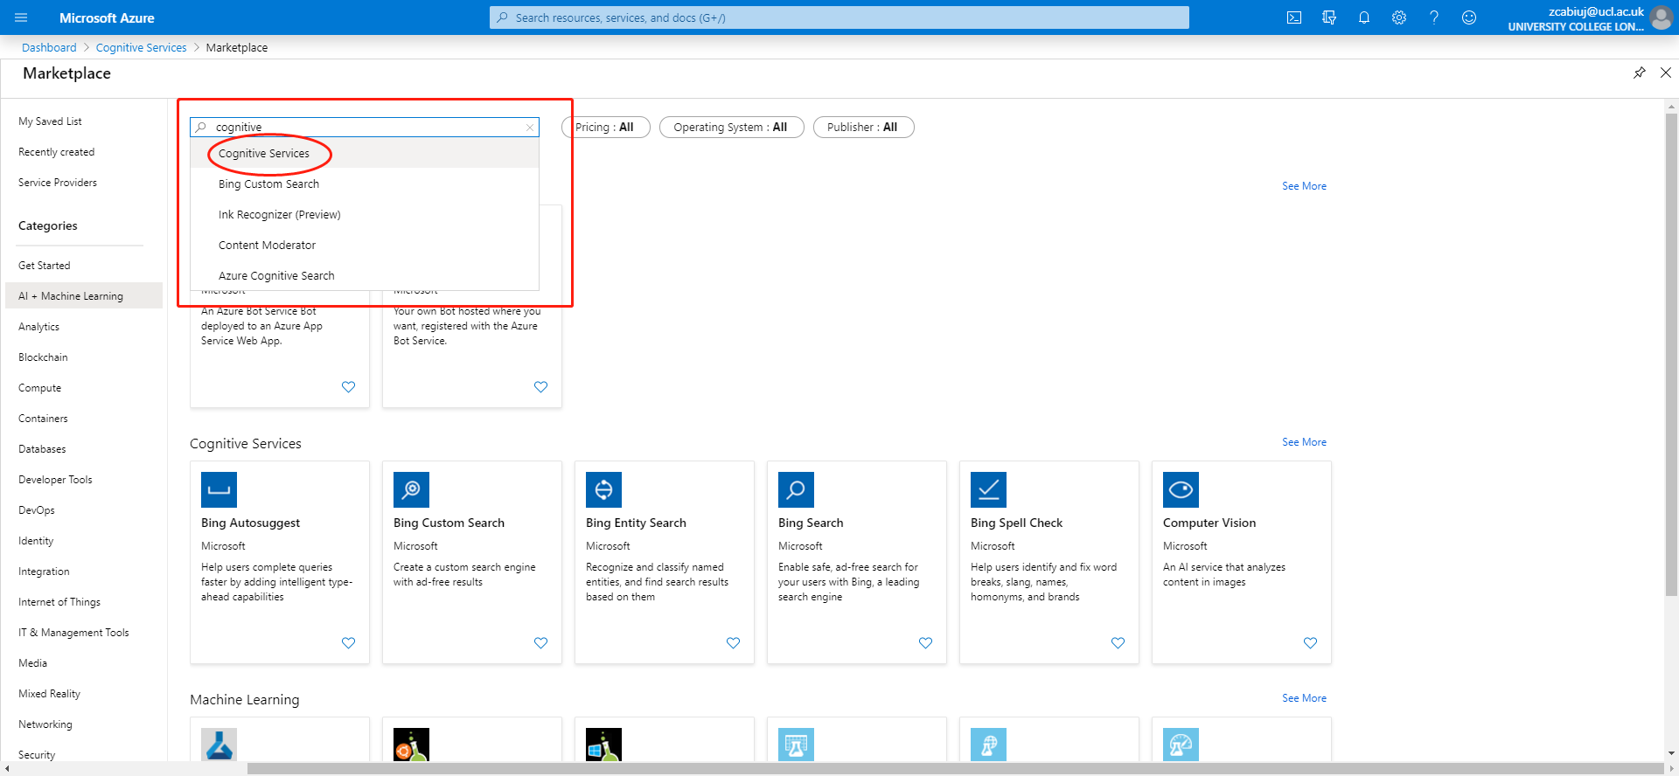
- 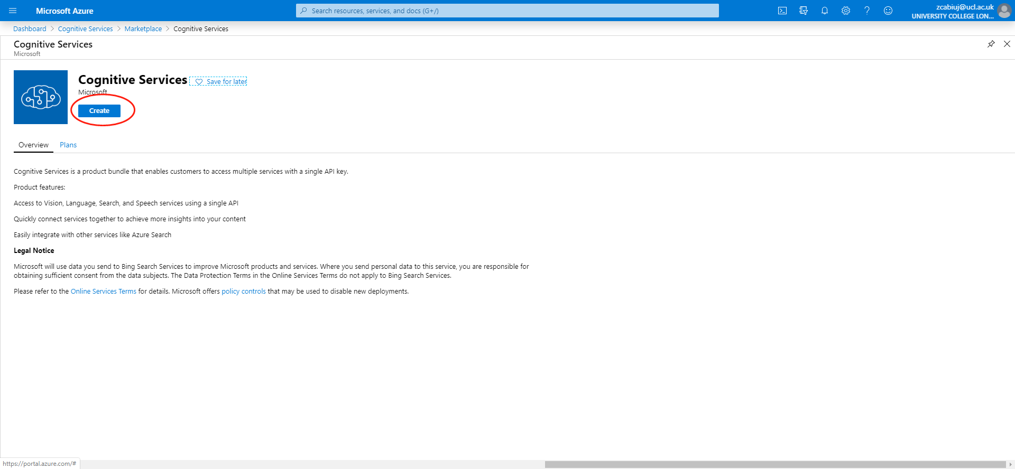
- 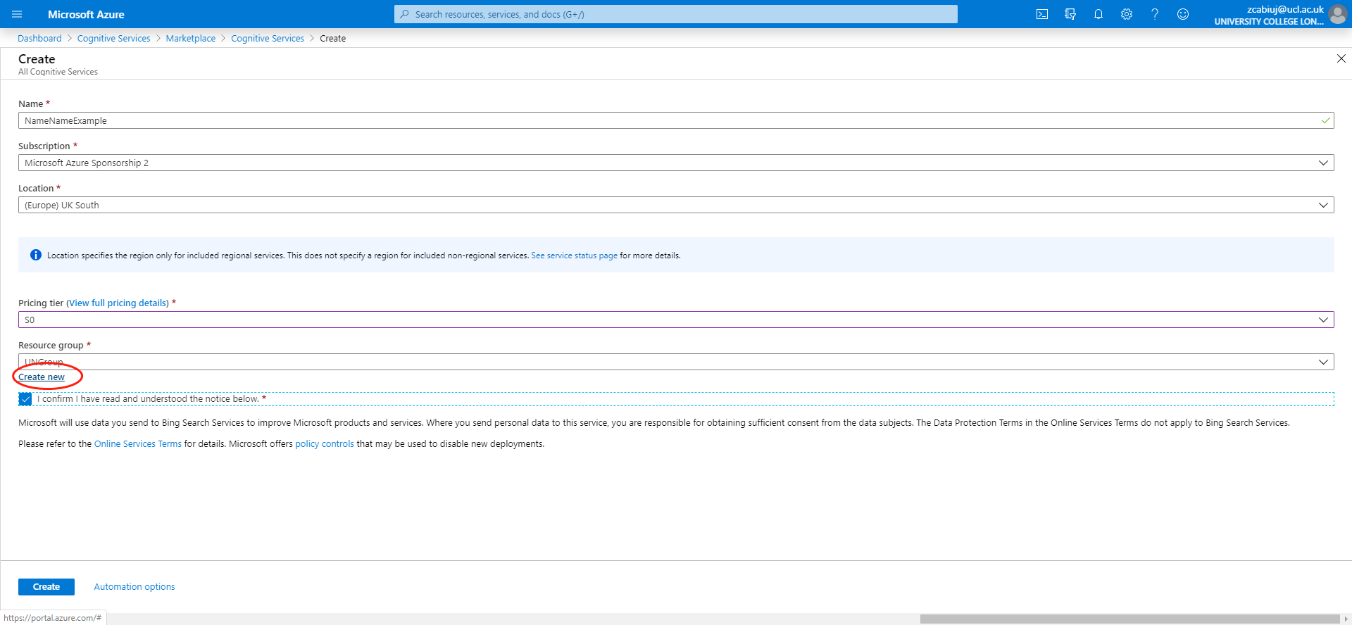
- 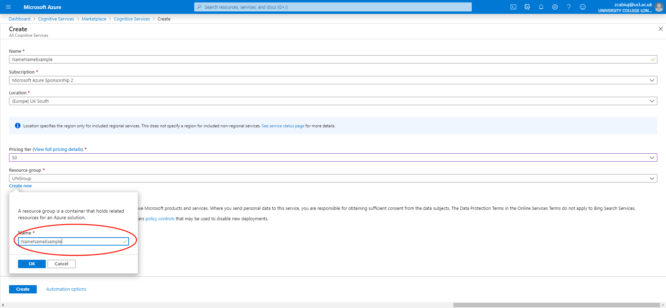
- 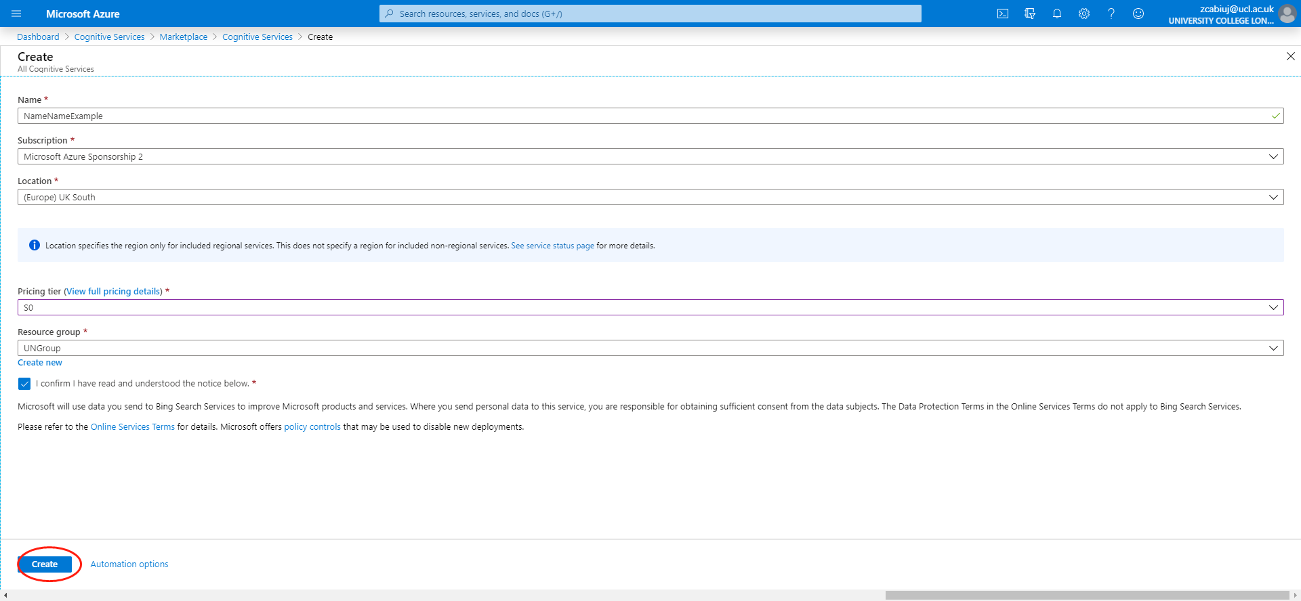
- Once you create the service account, go to service management page, go to quickstart
- Copy these two values they will be used in the following steps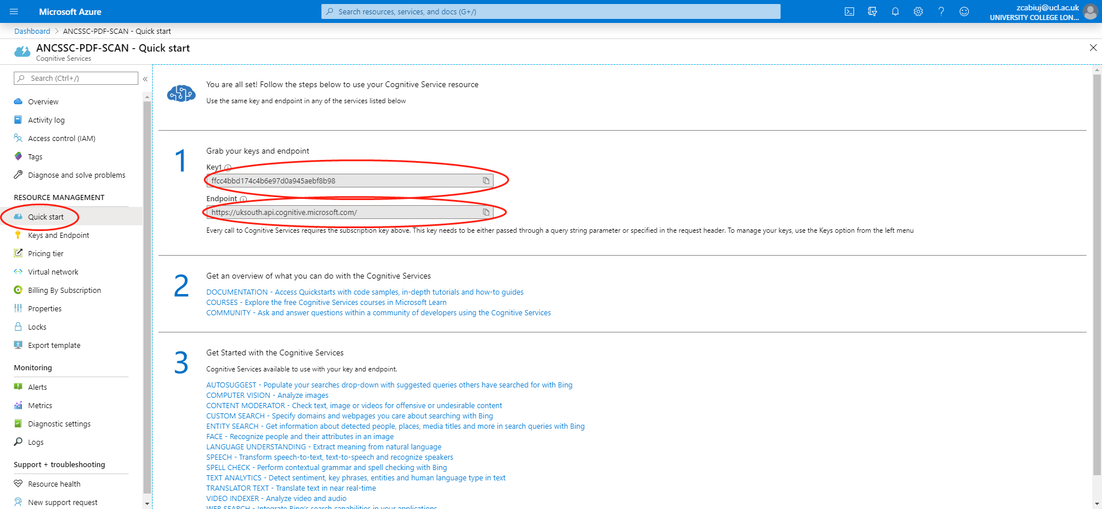
- Use them to replace the value of these two variables in the code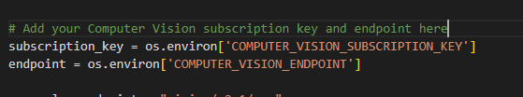
- Change the path to the training file and to the file that you want to analyze 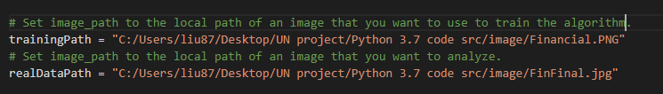
- open a command prompt and navigate to the folder of our project.
- Run the following command: python <project location>\mian.py

